**From Vision to Understanding: Leveraging VLMs to enable autonomous driving decisions.**

***Group Members***

* Sridharan Subramanian: ss233
* Brijesh Muthumanickam: brijesh2
* Murali Kartheek Gandiboyina: mkg7
* Sai Rohit Muralikrishnan: srm17

***Project definition and goals***

Our project focuses on integrating Vision Language Models (VLMs) with autonomous driving systems to enhance their decision-making capabilities and improve overall driving performance. VLMs, which are trained on large-scale web data, combine visual and language understanding, making them powerful tools for interpreting complex driving environments. By using these models, we aim to introduce advanced reasoning into autonomous systems, enabling them to make more informed and generalizable driving decisions.

The core idea behind our approach, called Drive Language Model, is to take visual input from multiple camera views and use the model’s reasoning ability to answer critical questions about driving situations, such as traffic conditions, potential hazards, or navigation choices. The ultimate goal is to create an end-to-end driving system that can respond intelligently to complex real-world scenarios, improving both safety and communication with users.

***Proposed approach***

*Tracking and optical Flow with Nanosam and Traditional CV*

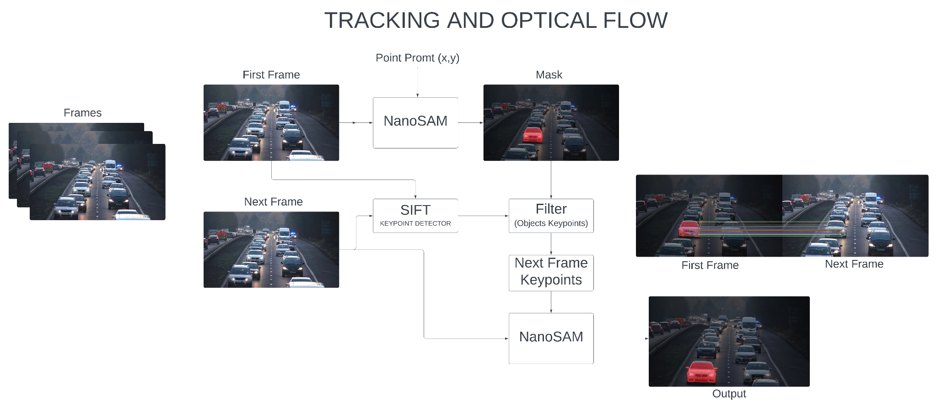

Nanosam is a zero-shot image segmentation algorithm that takes an image and a point prompt (usually pixel information) to identify the object of interest.

In our approach, we use Nanosam to achieve vehicle tracking/optical flow. For the first frame, we provide a user prompt indicating the location of the car to generate the initial mask. However, it's not feasible for the user to provide a prompt for each subsequent frame to identify the car. To address this, we use the SIFT keypoint algorithm to detect keypoints in both the initial and consecutive frames. We then filter the keypoints using the initial frame's mask. By matching the keypoints between frames, we use the matched points as a prompt for Nanosam to identify the mask in the successive frames.

This approach is powerful because it allows for robust tracking of objects, generating accurate masks without the need for tedious training.

*Ego Vehicle Motion+Pose estimation using optical flow*

We also take a look at one classical approach to achieve odometry. To use visual input as only sensor modality to determine the position, orientation of the ego vehicle. We also plan to check its feasibility to get the motion direction of the ego vehicle. This method uses the classical optical flow implementation from Lukas-Kanade method and/or the Gunnar-Farneback method to determine the motion flow gradient and magnitude. We implement dynamic parameter setting for this optical flow detection based on the class of the object it is extracted from. By combining with the YOLO11 to detect multiple classes of objects - including static and dynamic, the flow algorithm is optimized by focusing on the objects of interest (i.e, - cars, traffic lights, pedestrians, stop signs). The challenge in this approach is to estimate the motion and pose of the ego car in the frames where static objects are absent or go undetected - which happens often.

*KLT Optical Flow Approach*

Implemented a method that tracks image features using KLT optical flow and keeps a stable feature count by detecting new corners. Keyframes are chosen based on how much features appear to shift between frames which occurs when the camera viewpoint changes, revealing depth information. If the number of features drops too low, a new keyframe is created to maintain robust tracking. This approach did not function as expected with the nuScenes dataset.

*Next Steps with nuScenes and VLM Training*

Dataset preparation:

Our approach to handle Multi-view images:

1. *Orientation Labeling*: Assign a camera orientation label to each image (e.g., "CAM_FRONT") for context.
2. *Resizing*: Standardize each image by resizing to 896x448 pixels.
3. *Composite Creation*: Arrange the six images in a 2x3 grid to form a composite image sized 2688x896 pixels.
4. *Subdivision and Resizing*: Split the composite into twelve 448x448 sub-images (two per view) and create a 448x448 thumbnail of the full composite.
5. *Token Transformation*: Convert each 448x448 image into 256 tokens via a Vision Transformer Multilayer Perceptron (VIT-MLP) and pixel shuffle for model processing.

This enables high-resolution, multi-view integration while reducing processing overhead. Arranging and tokenizing views as a single composite image enhances spatial context and efficiency

*Model Architecture*: We plan to use **Llama 3.2-11B-Vision-Instruct** multivision model because of its multimodal data processing, enabling simultaneous interpretation of images and text. This capability allows for precise scene understanding, real-time hazard detection, and accurate interpretation of traffic rules.

*Model Fine-Tuning*: Role of Optical Flow and Object Tracking:

To enhance our vision-language model's performance, we integrate optical flow and object tracking into the fine-tuning process.

**Temporal Consistency**: Optical flow and tracking maintain object continuity across frames, enabling the model to learn object persistence, crucial for hazard detection.

**Enhanced Motion Features**: Tracking moving objects highlights dynamic features, allowing the model to distinguish between static and moving elements, refining feature extraction.

**Ego Motion-Pose Estimation**: Optical flow supports precise calibration for ego vehicle motion and pose estimation, enhancing the model’s spatial orientation accuracy in multi-view scenes.

**Dynamic Mask Generation**: Nanosam’s zero-shot segmentation provides adaptive, high-precision masks without re-training. These masks adjust to shifting object positions and occlusion status in varying lighting and environmental conditions, offering stable inputs for the model.

***Datasets***

We plan to first explore the open source datasets given below from nuScenes:

Training Dataset

[**https://drive.google.com/file/d/1DeosPGYeM2gXSChjMODGsQChZyYDmaUz/view**](https://drive.google.com/file/d/1DeosPGYeM2gXSChjMODGsQChZyYDmaUz/view)

Validation dataset

[**https://drive.google.com/file/d/18f8ygNxGZWat-crUjroYuQbd39Sk9xCo/view**](https://drive.google.com/file/d/18f8ygNxGZWat-crUjroYuQbd39Sk9xCo/view)

***Initial results***

* We use Nanosam to track a vehicle by creating an initial mask from a single user prompt. From there, we match keypoints across frames to help Nanosam follow the vehicle, allowing for accurate tracking without extra input or training.

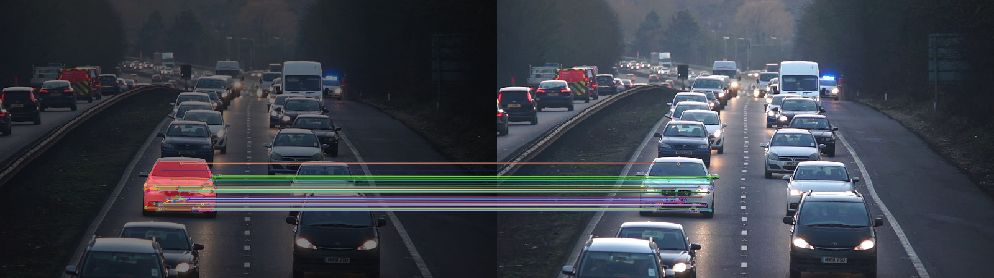

Left image is previous Frame Right image is Current frame



* Implementation of optical flow to perform scene understanding and motion and pose estimation of ego vehicles. We plan to achieve this in the autonomous driving setting with only cameras as the primary sensor modality. The algorithm is run on nuScenes Images dataset: It shows the optical flow extracted only from the objects of interest - in this case vehicles, pedestrians.

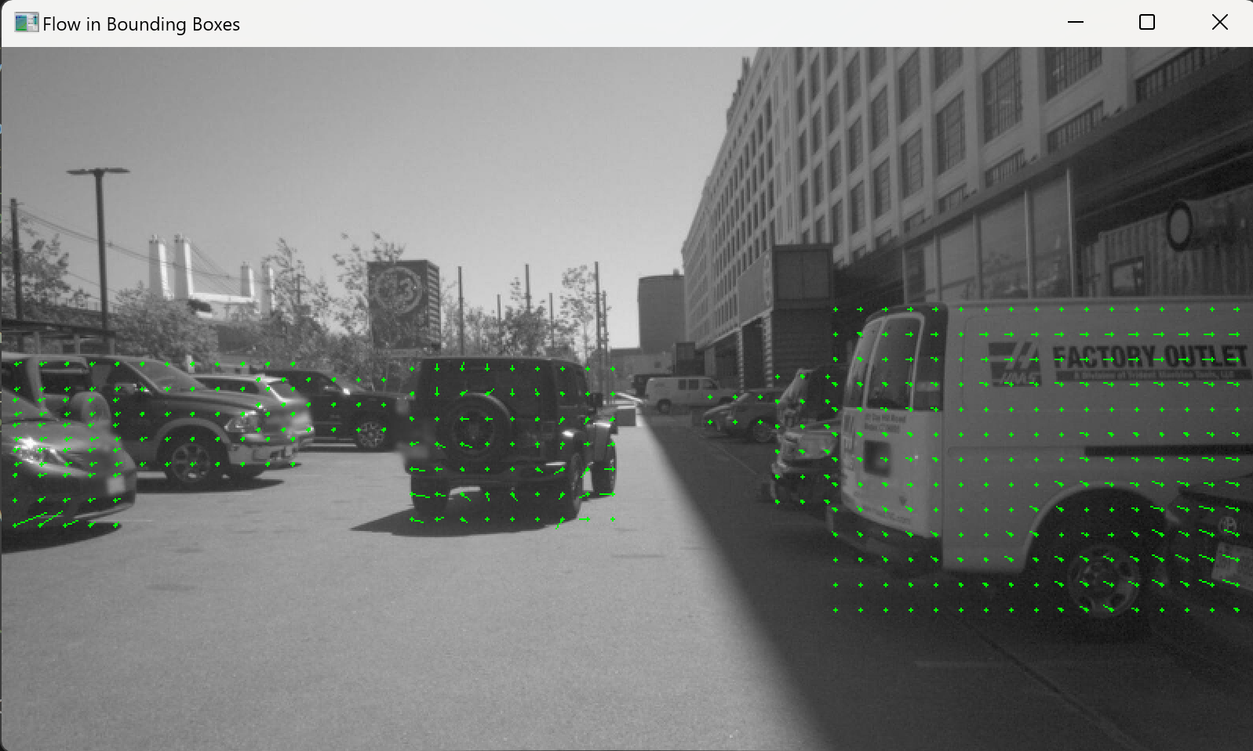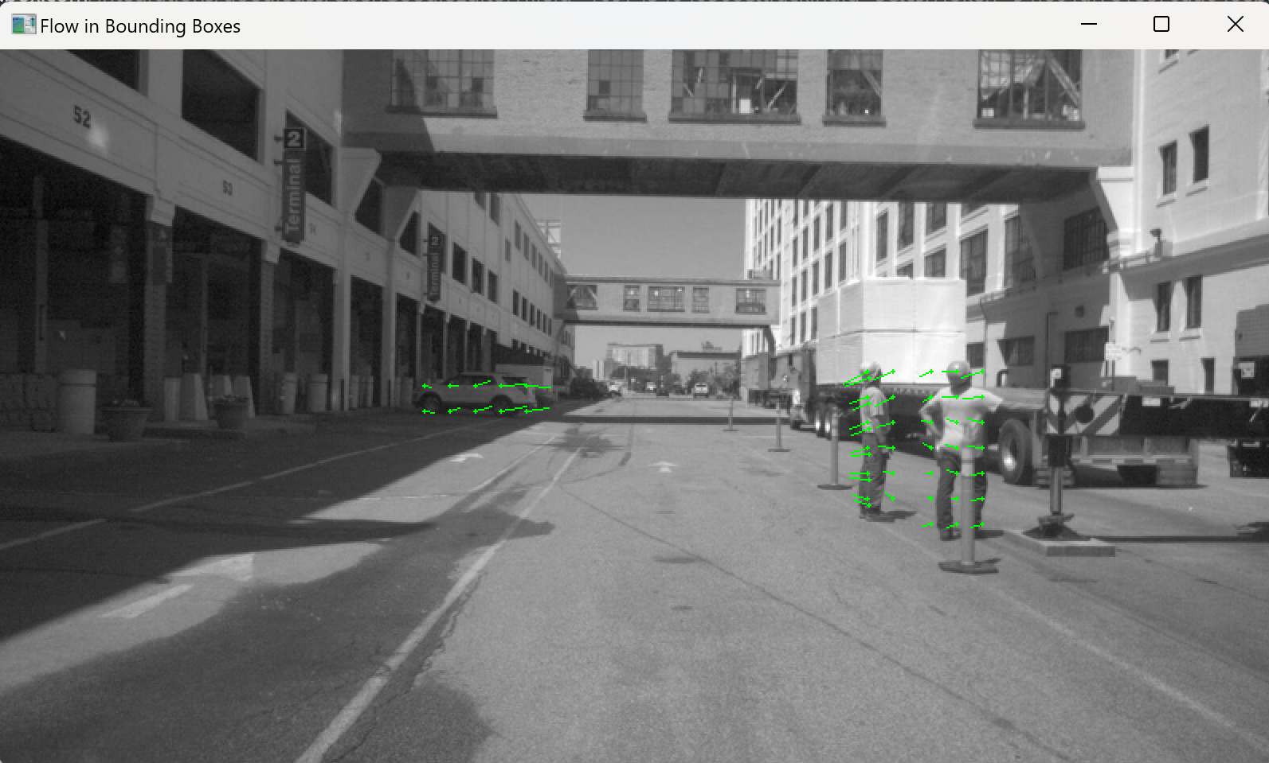

The loop's average time: 0.068 secs(to detect, extract bounding box and calculate optical flow in ROI)

***Current member roles and collaboration strategy***

We're using a GitHub repository to manage and share our code and data. Each person has assigned tasks, and we meet every 3–4 days to update each other on our progress and keep things on track.

Anticipated roles for everyone: Combine the results of individual tasks with VLM to aid its scene understanding better.

Kartheek Gandiboyina: Tracking and optical Flow with Nanosam and sift keypoint detector.

Sridharan Subramanian: Motion+Pose estimation using classic Optical Flow

Sai Rohit Muralikrishnan: Multi-view image, Token transformation, composite image creation.

Brijesh Muthumanickam: Explore 3D bounding boxes using classical approach

***References***

* <https://github.com/ultralytics/ultralytics>
* <https://docs.ultralytics.com/modes/predict/#key-features-of-predict-mode>
* Sima C., Renz K., Chitta K., Chen L., Zhang H., Xie C., *et al.*, DriveLM: Driving with Graph Visual Question Answering, arXiv.Org, 2023, abs/2312.14150
* Qin T., Li P., Shen S., VINS-Mono: A Robust and Versatile Monocular Visual-Inertial State Estimator, IEEE Transactions on Robotics, 2018, 34, 1004–1020
* <https://docs.opencv.org/4.x/da/de9/tutorial_py_epipolar_geometry.html>
* <https://github.com/binh234/nanosam>
* Motional. (n.d.). *GitHub - motional/nuplan-devkit: The devkit of the nuPlan dataset.* GitHub. <https://github.com/motional/nuplan-devkit>
* Gopalkrishnan, A., Greer, R., & Trivedi, M. (2024). Multi-Frame, Lightweight & Efficient Vision-Language Models for Question Answering in Autonomous Driving. *arXiv preprint arXiv:2403.19838*.
* <https://github.com/OpenGVLab/InternVL>
* Makiyeh, F., Bastourous, M., Bairouk, A., Xiao, W., Maras, M., Wangb, T. H., ... & Rus, D. (2024). Optical Flow Matters: an Empirical Comparative Study on Fusing Monocular Extracted Modalities for Better Steering. *arXiv preprint arXiv:2409.12716*.